

OVERVIEW

Developer Dennaton Games Publisher Devolver Digital
Genre Indie, Action Release 2013
Platforms PC | Mac | Linux Price TBD

A brutal conclusion to the gruesome saga, Hotline Miami 2: Wrong Number follows the escalating level of violence through multiple factions born from the events of the original game and driven by uncertain motivations. Step into the murderous mind of several distinct characters - each with their own motivations and methods of execution – as storylines intersect and reality slips away into a haze of neon and carnage. Blistering combat, an unmistakable visual style, and a powerfully intense soundtrack will once again push you to the limit and questioning your own thirst for blood.

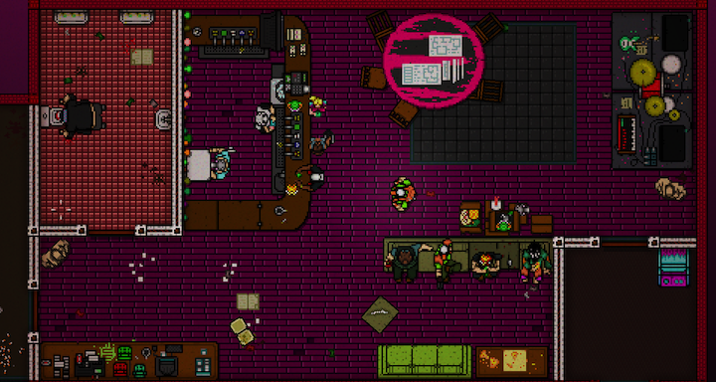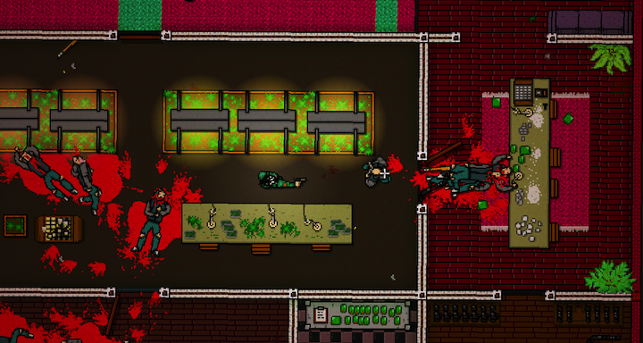

FEATURES

- Twenty brutal chapters twisting through interconnected storylines, each set against a variety of new locations and time periods.

- Delve into a world of violence with unique gameplay styles and savage new weapons through different playable characters throughout the game.

- Hundreds of new sprites and animations in the distinct visual style create lush new areas to clear floor-by-floor and a driving new soundtrack keeps your heart racing and begging for more.

MORE INFO

Website: hotlinemiami.com
Facebook: facebook.com/hotlinemiami
Twitter: @hotlinemiami

